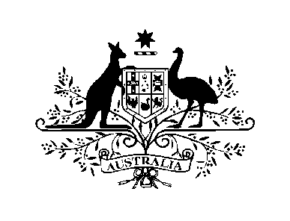
AUSTRALIAN HIGH COMMISSION
BANDAR SERI BEGAWAN

Australian Community Outreach

The Australian High Commission in Brunei Darussalam maintains contact information for Australian citizens and their families residing in Brunei in order to share information about social and community events (for example, Australia Day and Anzac Day). Any details provided will be handled in accordance with Australian privacy legislation.

If you are not currently on the High Commission mailing list, or your contact information has recently changed, please complete the attached form and email it to austhicom.brunei@dfat.gov.au.

Information on High Commission events can also be found on our website or Facebook page.

Consular and Contingency Planning

Please note this Australian Community Outreach form will not be used for consular or crisis purposes. The High Commission strongly encourages Australian citizens holidaying, working, studying or living in Brunei to visit the Smartraveller website to register so that we can contact you in the event of a crisis. You may also wish to subscribe to alerts. This is a free email service to provide you with the latest updates to our travel advice. You can subscribe to one or more countries or to bulletins about topics such as voting in Australia, large sporting events, or widespread health or security issues.

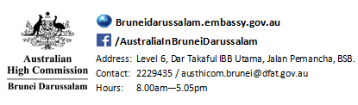

Australian Community Outreach Form

 | SURNAME  (please underline your surname) |  | First Name |  | AUSTRALIAN  CITIZEN
Full Name  (primary contact) |  |  |  |  | Yes / No
Full Name  (accompanying family member) |  |  |  |  | Yes / No
Full Name  (accompanying family member) |  |  |  |  | Yes / No
Full Name  (accompanying family member) |  |  |  |  | Yes / No
Full Name  (accompanying family member) |  |  |  |  | Yes / No
Mobile (primary contact) |  |  |  |  | Yes / No  Please indicate if you would be willing to receive occasional Whats App messaging
Personal Email address (primary contact)
Work Email (optional)

Information is sought in order to keep Australian citizens and their families in Brunei informed of Australian High Commission activities. Information is covered by Australia’s Privacy Act 1988 (Cth). Please email your completed form to austhicom.brunei@dfat.gov.au and we will add your details to our mailing list.

